1. Process: User Registration Process
2. Purpose: Register users of the system and assign various roles to them
3. Screens in this process

|  |  |  |
| --- | --- | --- |
| **Screen Name** | **Purpose** | **Access By User Role** |
| Register New staff | To register new staff as users | IUMSADMIN or College AD.  IUMSADMIN user can register users for any institute in the system. College AD can register users only for his own institute |
| Maintain User Roles | To assign various roles to the users | IUMSADMIN or College AD. IUMSADMIN user can assign any roles to the users of any institute. College AD user can assign only College level roles to the users of his own college. |

1. Screens:

4.1 Login Screen:

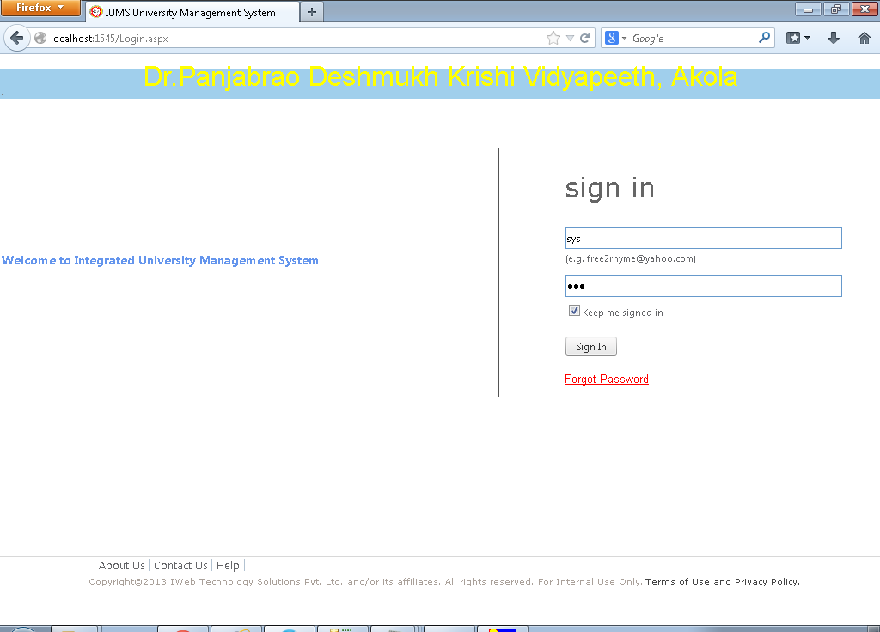

Screen Operation:

Enter the login Id and Password in the text boxes provided. Click on Sign In button.

Login with SYS user (a special user in the system having System Administrator role) or College AD user (Principal of a college).

SYS user can create University staff or College AD of each college.

College AD can create other staff (course teachers etc.) of his/her own college only.

4.2 Staff Registration (First Tab – Basic Profile)

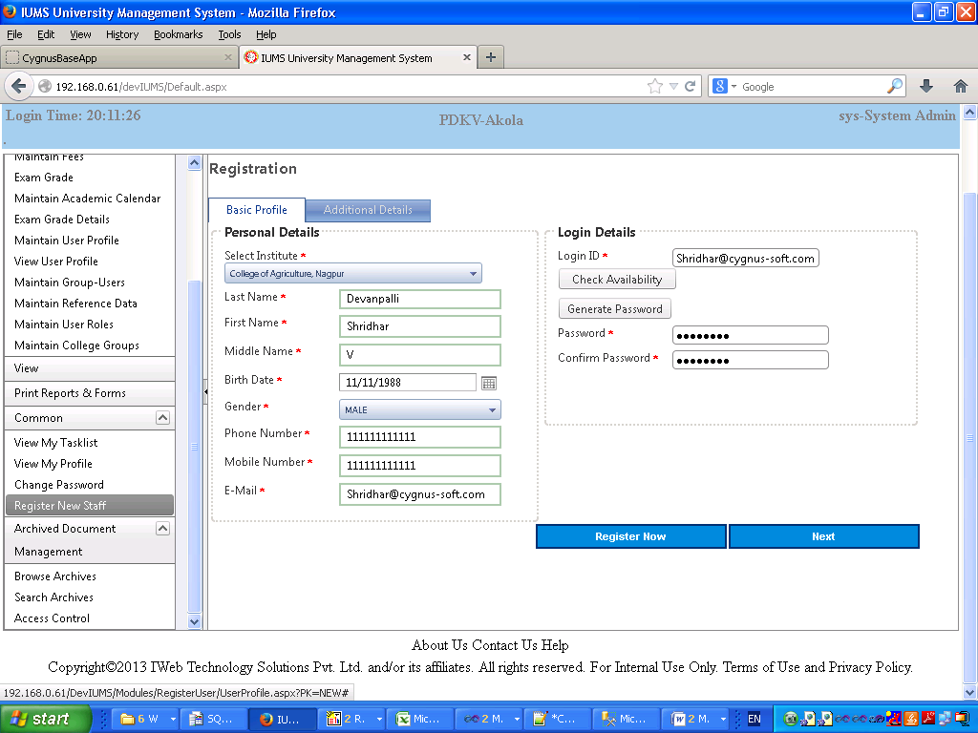

Screen Operation: Enter all the mandatory fields. Click on Register Now button if you want quick registration. If you wish to fill in additional details, then click on Next button.

Basic Profile (Personal Details)

|  |  |  |  |
| --- | --- | --- | --- |
| **Field Name** | **Description** | **Mandatory/Optional** | **Validation** |
| Institute | Select from drop down list the institute in which the user normally works. For College AD login, this field is already set and cannot be changed. | Mandatory | Selection only |
| Last Name | Enter last name of the user | Mandatory | Alphanumeric |
| First Name | Enter first name of the user | Mandatory | Alphanumeric |
| Middle Name | Enter middle name of the user | Mandatory | Alphanumeric |
| Birth Date | Enter Birth Date of the user | Mandatory | Date |
| Gender | Select gender of the user from the dropdown | Mandatory | Selection only |
| Phone Number | Enter phone number of the user | Mandatory | Numeric |
| Mobile Number | Enter mobile number of the user | Mandatory | Numeric |
| Email | Enter email address of the user | Mandatory | Valid email address |

Basic Profile (Login Details)

|  |  |  |  |
| --- | --- | --- | --- |
| **Field Name** | **Description** | **Mandatory/Optional** | **Validation** |
| Login ID | Enter a login id of this user, by default the email address will be copied here | Mandatory | Alphanumeric |  |  |
| Check Availability | Click this button to check if the login id is available in the system | Optional | Click only |
| Password | Enter password for this user | Mandatory | Alphanumeric minimum 8 characters maximum 18 characters |
| Generate Password | Click this button to generate a random password for this user | Optional | Click only |
| Confirm Password | Enter the password once again to confirm | Mandatory | Same as password |

4.3 Staff Registration (Second Tab – Additional Details)

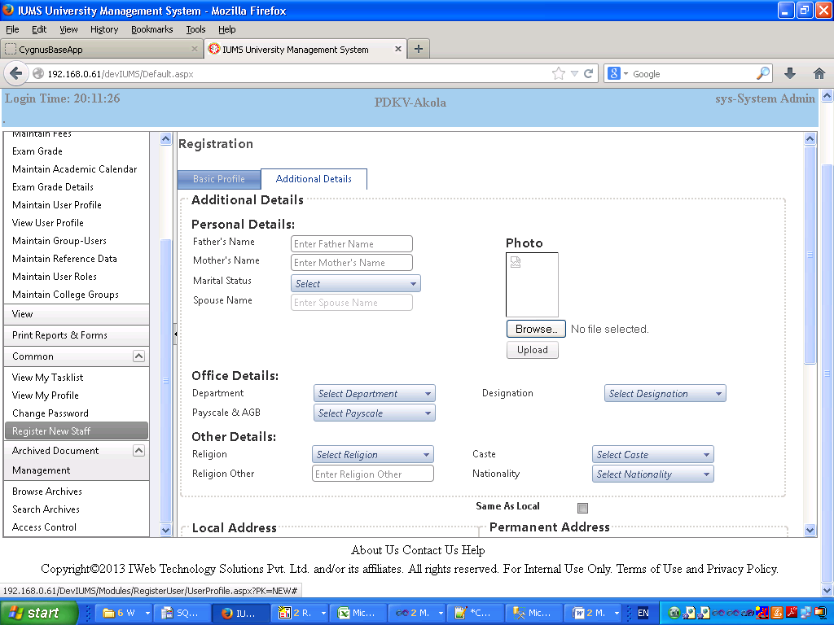

Screen Operation: Enter data in all mandatory fields. Enter data in Optional fields if you want.

Then click on the Register Button. The message “Data Saved Successfully” will be displayed.

|  |  |  |  |
| --- | --- | --- | --- |
| **Field Name** | **Description** | **Mandatory/Optional** | **Validation** |
| Father’s Name | Enter father’s name | Optional | Alphanumeric |
| Mother’s Name | Enter mother’s name | Optional | Alphanumeric |
| Marital Status | Select marital status from dropdown | Optional | Select only |
| Spouse Name | Enter spouse name | Optional | Alphanumeric |
| Photo | Browse & select the photo image file. Click Upload button. | Optional | JPG image file of size < 100KB |
| Department | Select department from dropdown | Optional | Select only |
| Designation | Select designation from dropdown | Optional | Select only |
| Pay Scale | Select Pay scale from dropdown | Optional | Select only |
| Religion | Select religion from dropdown | Optional | Select only |
| Religion Other | If the religion is not present in the dropdown, select Other and input the religion name here | Optional | Alphanumeric |
| Caste | Enter caste of the user | Optional | Alphanumeric |
| Nationality | Select Nationality from dropdown | Optional | Select only |

4.4 Staff Registration (Second Tab – Additional Details – Part 2)

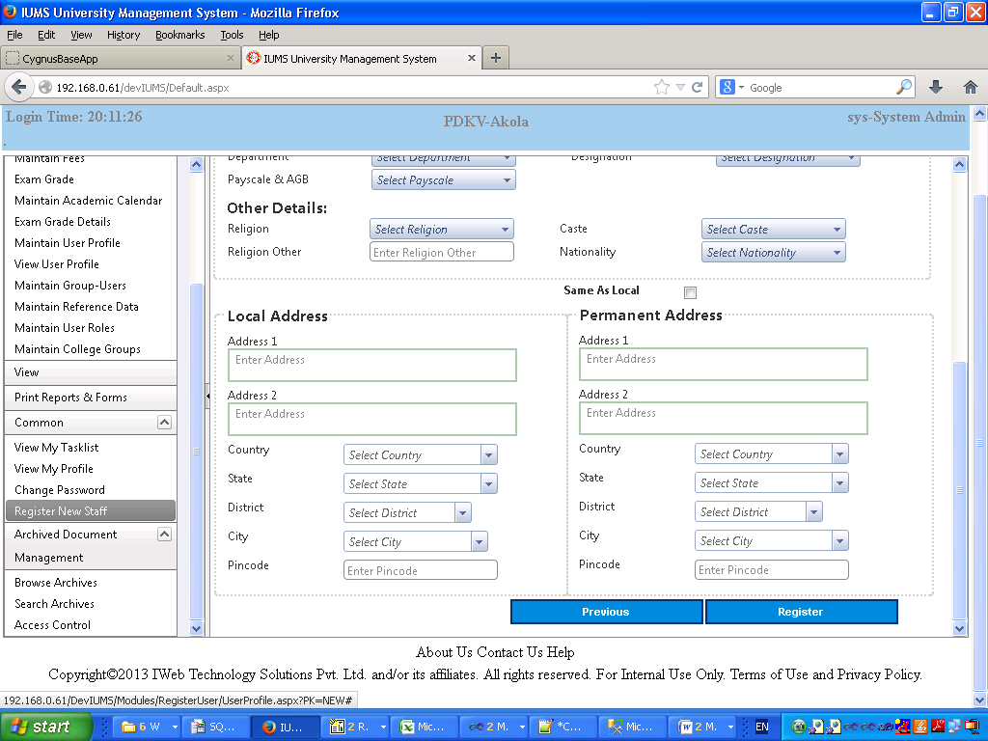

Local Address

|  |  |  |  |
| --- | --- | --- | --- |
| **Field Name** | **Description** | **Mandatory/Optional** | **Validation** |
| Address 1 | Enter 1st line of address | Optional | Alphanumeric |
| Address 2 | Enter 2nd line of address | Optional | Alphanumeric |
| Country | Select country from dropdown | Optional | Select only |
| State | Select state from dropdown | Optional | Select only |
| District | Select district from dropdown | Optional | Select only |
| City | Enter City | Optional | Alphanumeric |
| Pin code | Enter pin code | Optional | Alphanumeric |

Permanent Address

|  |  |  |  |
| --- | --- | --- | --- |
| Field Name | Description | Mandatory/Optional | Validation |
| Same as Local | Check the checkbox if permanent address is same as local | Optional | Check only |
| Address 1 | Enter 1st line of address | Optional | Alphanumeric |
| Address 2 | Enter 2nd line of address | Optional | Alphanumeric |
| Country | Select country from dropdown | Optional | Select only |
| State | Select state from dropdown | Optional | Select only |
| District | Select district from dropdown | Optional | Select only |
| City | Enter City | Optional | Alphanumeric |
| Pin code | Enter pin code | Optional | Alphanumeric |

4.5 Maintain User Roles

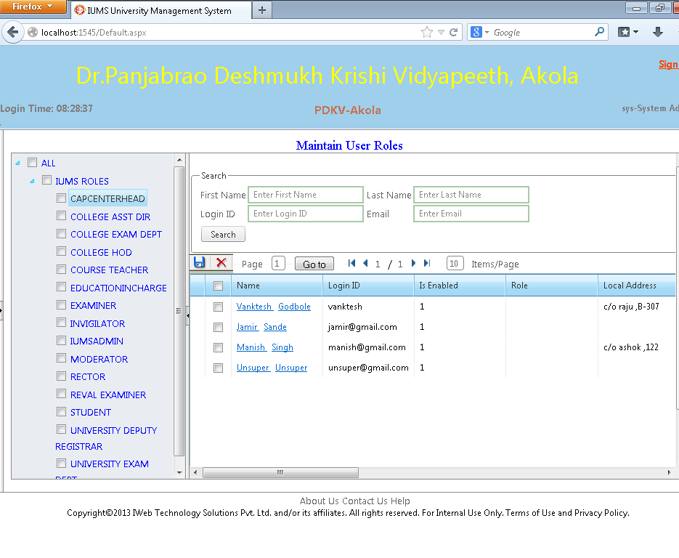

Screen Operation:

1. To assign a role to a user: Search an employee by his First/Last name, Login name or email id.

Check the checkbox to the left of the desired employee, Check the check box of the Role which you want to assign him under IUMS Roles in the Left pane. Click on the Save button.

1. To view the list of employees assigned a specific role: Click and Select a Role in the Left Pane.

1. To take away a role given to the user: Click on the Role which you want to take away in the Left Pane. All the users who have been assigned that role will be shown. Check the checkbox of the desired employee. Click on the Delete button.

|  |  |  |  |
| --- | --- | --- | --- |
| **Field Name** | **Description** | **Mandatory/Optional** | **Validation** |
| First Name | Enter first name of the user to search | Optional | Alphanumeric |
| Last Name | Enter last name of the user to search | Optional | Alphanumeric |
| Login Id | Enter login id of the user to search | Optional | Alphanumeric |
| Email Id | Enter email id of the user to search | Optional | Alphanumeric valid email id |
| Search (Button) | Click on the button to display matching user records | Optional | Click only |
| Save (Icon) | Click to assign the selected role to the selected users | Optional | Click only |
| Delete (Icon) | Click to remove the selected role from the selected users | Optional | Click only |